Attendance:

Meeting called to order: called the meeting to order at pm

Approve minutes: moved to approve the minutes,
Seconded, approved

Master Calendar
- BOD, February 2, 2021 7:00 pm via Zoom
- BOD, March 2, 2021 7:00 pm via Zoom

Committee Updates
Chairperson (Shawn Felts)
-Action Item - Crystal to set up Shawn on Instagram, Facebook and
emails

Vice Chair (Crystal Martinez)
-Action Item- Cristina to compile a current list to parse down
-annual renewal of Hostway is $12
-Action Item- Cristina to do a cost analysis between Constant Contact
and Wild Apricot for mass email costs and capabilities

Secretary Report (Lisa Molaro)
-Action Item - produce regular Muddy Hands reports, meet with Crystal regularly

Financial Report (Cristina Chang)
-Paid Adobe
-Paid Wild Apricot
-Paid Hostway
-Account balances:
Checking:
- Action Item - investigating Hostway v.s. Other hosting/email services.
Hostway -> mailman, not user friendly
The Newletter Broadcast -> 100 contact $10 unlimited emails/ month
- resolving 2106 tax dispute

Membership (Crystal Martinez)
- total membership is active members and up for pending
- corporate members

Workshops (open)

Clay Dates (Lisa Molaro)
- Action Item - revive monthly “General Meeting” with Theme, Purpose
and Demo

Sales (Gina Hausmann, Lisa Molaro)
- look into the feasibilty of Pop Up Sales, permits and insurance

Exhibits Committee (Marilyn Host)

Muddy Hands, Web Site & Social Media (Susanne Edgerton)
- Muddy Hands - report on Filoli, new board members and AIC
- Action Item - Ask Susanne about the feasibility of moving the OVCAG
videos on YouTube to the OVCAG account
- Action Item - Lisa to pick up OVCAG equipment from Susanne and
move it into storage
- Action Item - Crystal to get YouTube log in information - Action Item - put out a call in Muddy Hands for Susanne’s position

Meeting Adjourned
Shawn adjourned the meeting at pm.

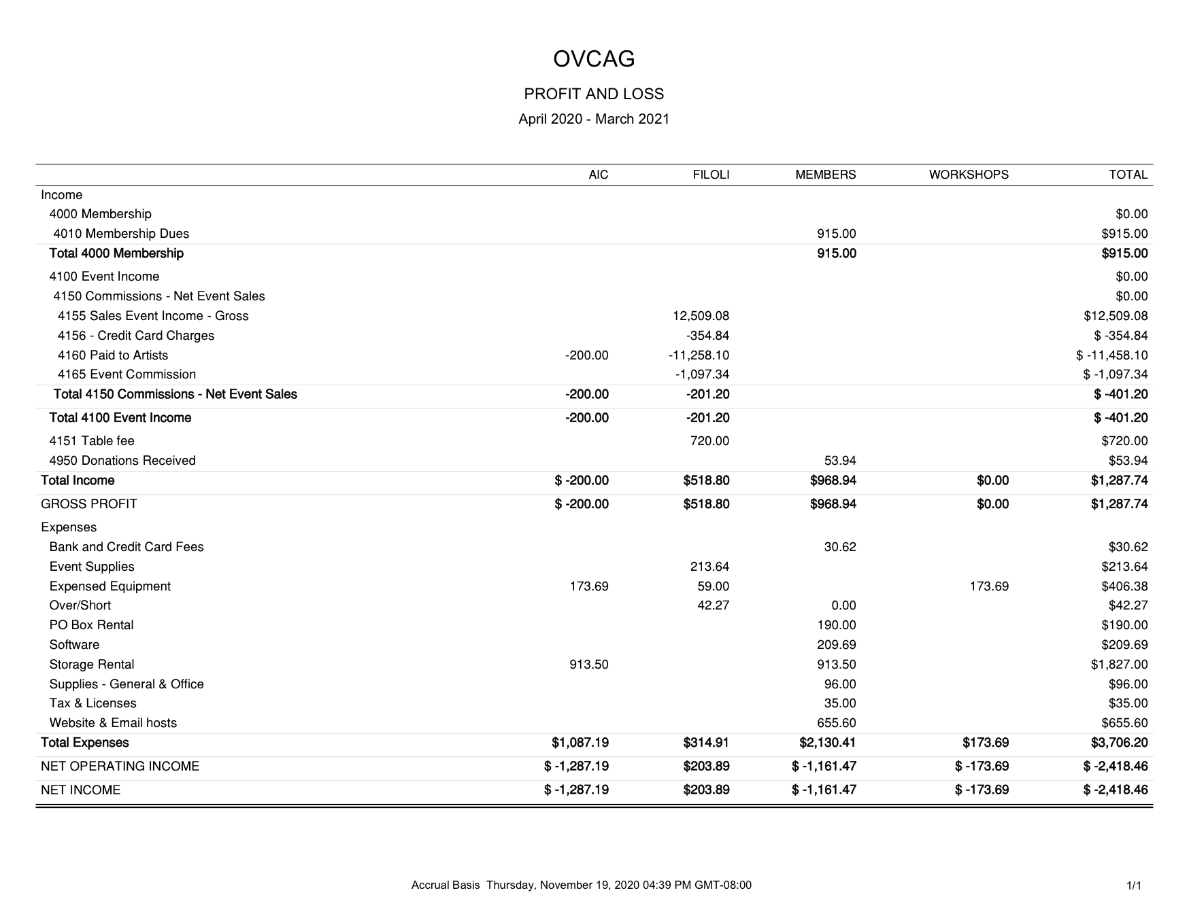
Reports

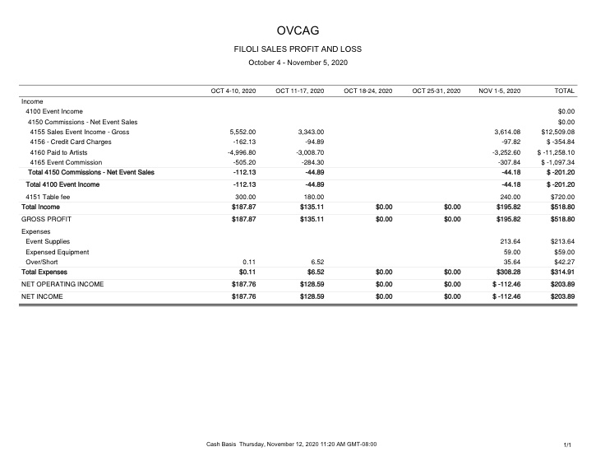

NAME | RESPONSIBILITY | PHONE | EMAIL (personal)
Shawn Felts | Chairperson | 502-387-0495 | shawnfelts@gmail.com
Crystal Martinez | Vice-Chairperson | 408-821-9949 | crystalleemartinez.com
Cristina Chang | Treasurer | 650-383-8593 | wishwerks@gmail.com
Lisa Molaro | Secretary | 408-863-0112 | lisa@molaro.org
Gina Hausmann | Sales Co-Chair | 408-973-0274 | ginahsm4@gmail.com
 | Workshops
Crystal Martinez | Membership | 408-821-9949 | crystalleemartinez.com
Linda Mau | Member Emeritus | 408-781-8701 | linda@lmau.com

COMMITTEES

NAME | RESPONSIBILITY | PHONE | EMAIL (personal)
Henriette Pons-Conte | Sales Co-Chair | 650-644-7581 | henriett.pnte@gmail.com
Crystal Martinez | Website, Muddy Hands | 408-821-9949 | crystalleemartinez.com
Susanne Edgerton | Social Media | 408-940-2172 | smedgerton@yahoo.com
Lisa Molaro | General Meeting, Presentations | 408-863-0112 | lisa@molaro.org
Marilyn Host | Exhibits |  | marhost@sbcglobal.net
 | C.A.P. Coordinator
 | Volunteers

